**Title : MediEase**

**Group ID:6**

|  |  |
| --- | --- |
| **Student ID** | **Student Name** |
| **444009063** | **Elaf AlOtaibi** |
| **444009259** | **Lama Alshaiban** |
| **444009129** | **Marianna Alghamdi** |
| **444009104** | **Wafa Alzahrani** |
| **444009073** | **Joud Alshehri** |

Contents

**1.Introduction:**. 4

**2.Problem statement:** 4

**3.Methodology with justification:** 5

**4.Project charter:** 7

**5.Techniques for Collecting Requirements** 11

**6.Project requirements** 12

**7.Scope Statement :** 13

14

**7.WBS and WBS dictionary :** 15

**8.RACI chart** 20

**9.Gantt chart** 20

**10.Risk register** 25

**11.References:** 26

Table of Figures

Figure 1: Project Charter 7

Figure 2: Project Charter 8

Figure 3: Project Charter 9

Figure 4: Project Charter 10

Figure 5: Project Scope Statement 13

Figure 6: Project Scope Statement 14

Figure 7: Work Breakdown Structure 15

Figure 8: Gantt chart……………………………………………………………………….24

Figure9: Risk Register……………………………………………………………………..25

Table of Tables

Table 1: WBS Dictionary 14

Table 2: RACI Matrix 19

Phase 1:

# **1.Introduction**

Nahdi is a mobile app made by Nahdi Pharmacy in Saudi Arabia to make it easier for people to shop for medicine and health products. The app helps users order items, track their deliveries, and get special offers. It also lets users chat directly with a pharmacist to ask questions or get advice. The app is easy to use and was created to improve the overall customer experience and support digital health services.

# **2.Problem statement**

The Nahdi Pharmacy app currently lacks features, like advanced searches, symptom-based diagnosis, and ingredient reviews. After the initial changes have been applied, users will now be able to filter medicines based on their symptoms through an advanced search option. The app will also include a Diagnoser feature, allowing users to type in a few symptoms and receive a preliminary diagnosis along with recommendations for suitable items. Furthermore, the app will also feature ingredient analysis to better target users pharmaceutical needs, Improving user experience in digital health applications helps accelerate the adoption of digital health services. [1]

# **3.Methodology with justification**

Based on the nature of products offered by Nahdi, particularly medicines and health products, testing carries significant risks. Therefore, the selected approach should aim to minimize the impact on patients’ safety, because this may lead to medication errors and could lead to significant consequences on healthcare outcomes. Scrum is the most suitable approach because it allows for incremental testing after each planning phase, helping to mitigate these risks. Despite the fact that some other methodologies, like Waterfall (a predictive model) provide certain advantages, they may require testing features all at once. In this case, we are managing an application that could jeopardize patients’ life as many patients, especially patients suffering from chronic diseases such as hypertension and diabetes, rely on the app to manage and refill their prescriptions. Scrum’s approach of breaking down features into smaller, more manageable pieces helps ensure a safer and more controlled implementation. Testing each feature incrementally ensures that any errors can be identified and resolved quickly.

**Product Backlog User Stories:**

1. **Advanced Search Functionality**

* **User Story:** As a user, I want to filter medicines by symptoms or ingredients so that I can find the right products for my health needs.

1. **Diagnoser Feature**

* **User Story:** As a user, I want to input my symptoms into the app so that I can get a preliminary diagnosis and product recommendations.

1. **Ingredient Analysis**

* **User Story:** As a user, I want to see detailed information about the ingredients in a product so that I can make an informed decision.

**Sprint Planning:**

* **Sprint 1: Building the Advanced Search Feature**
* Sprint Duration: 2 weeks
* Tasks: Develop and implement the filtering system for symptoms and ingredients.
* Outcome: By the end of this sprint, users will be able to search for medicines by symptoms and ingredients.
* **Sprint 2: Adding the Diagnoser and Ingredient Analysis Features**
* Sprint Duration: 2 weeks
* Tasks:
* Create a feature where users can input their symptoms, and the app will suggest potential diagnoses and recommend suitable products.
* Develop a section that provides detailed information about the ingredients in each product, so users can make informed decisions.
* Outcome: After this sprint, users will be able to enter their symptoms into the app and get product recommendations, as well as learn about the ingredients in the medicines they’re considering.

# **4.Project charter**

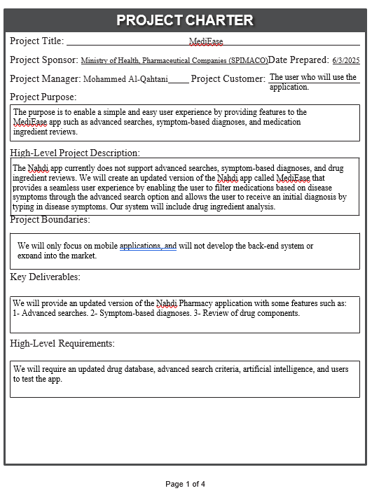

Figure 1: Project Charter

صورة تحتوي على نص, لقطة شاشة, رقم, المستند

قد يكون المحتوى المعد بواسطة الذكاء الاصطناعي غير صحيح.

Figure : Project Charter

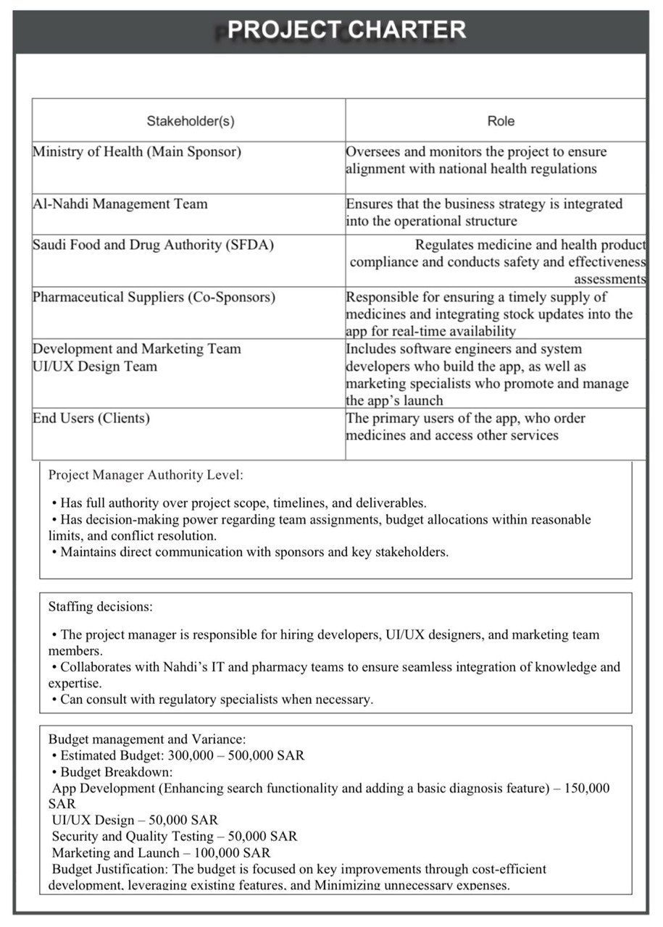

Figure : Project Charter

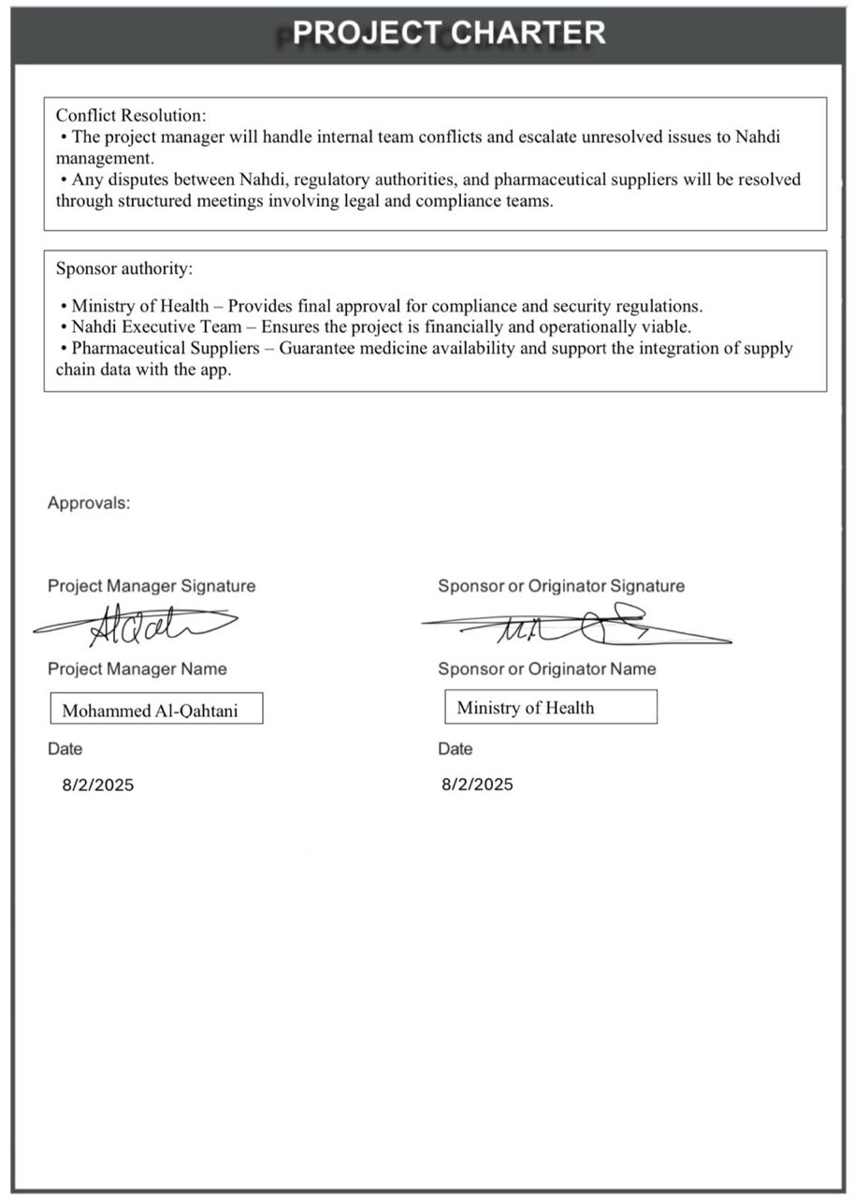

Figure : Project Charter

# 

# **5.Techniques for Collecting Requirements**

• Interviews: For gathering detailed and specialized information from user cases like patients and pharmacists regarding the features they want in the app, for example advanced diagnosis search, consider conducting interviews. This technique was selected due to the simplicity of collecting rich information that is relevant to the problems.   
  
• Questionnaires: Develop an electronic questionnaire and use it to gather relevant information from a large audience. This is particularly applicable to estimate the level of interest resulting from features embedded in the ammunition such as diagnosis and ingredient display.   
  
• Observation: Study the manner in which the users navigate and operate the current app so that aspects of the interface that are difficult for users, for example, getting information as well as searching for it, are easily accessible and usable. It is often necessary to deal with problems that are hidden and not readily stated, and this technique reveals them.  
  
• Workshops: Arrange meetings organized in an interactive manner where users, developers, and designers meet to brainstorm for the purpose of capturing all required features and some concepts including “Diagnoser” or ingredient analysis.  
  
• Document Analysis: Analyze documents of applications under examination or other digital health applications that are available in the market in order to derive general and particular requirements with regard to the domain of the health technology.[3]  
  
Justification: These techniques are necessary for the project, as the target concern deeply relates to users’ health. It is important that all requirements that need to be collected are accurate to avert error

**6.Project requirements**  
Software:  
  
- Applicants must be skilled in mobile programming: Swift for iOS and Kotlin for Android.   
  
- Android Studio or Xcode.   
  
- Artificial Intelligence Integrated with the Diagnoser Function.  
  
- UI data processing and storage requires Dedicated Servers.  
  
Hardware:  
  
- Candidates must possess Smartphones which always need to have the latest app version installed.  
  
- Need Servers for advanced data processing and analysis, including the use of AI.  
  
  
Functional Requirements:   
  
- Searching for advanced medicine by describing symptoms or listing ingredients.  
- Preliminary diagnosis feature (Diagnoser).  
- In-depth ingredient scrutiny of individual products.  
- Receiving offers and notifications.  
- Communicating directly with pharmacists.   
  
Non-Functional Requirements:   
  
Protection of user health information falls under security.   
Fast reaction to symptom entry and result display under performance.   
Simple and hassle-free design applicable to all demographic groups under usability.   
Ability to easily add future features under scalability.

# **7.Scope Statement**

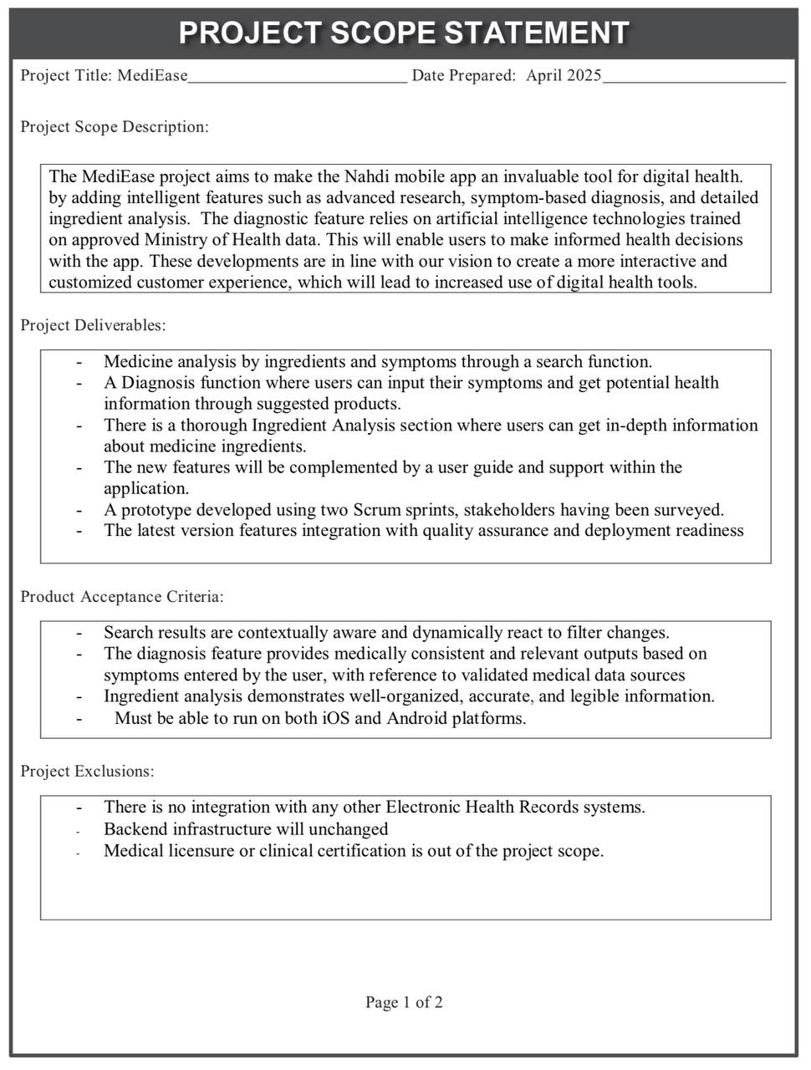

Figure 5: Project Scope Statement

Figure 6: Project Scope Statement

# **8.Work Breakdown Structure**

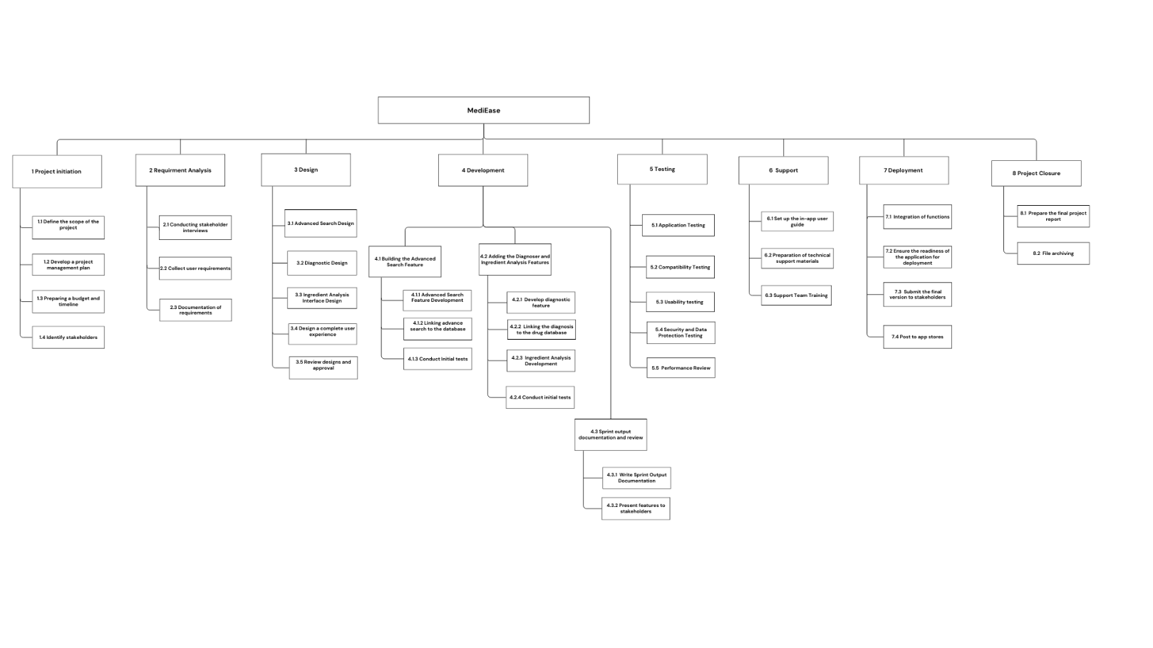

Figure 7: Work Breakdown Structure

# **WBS Dictionary**

Table 1: WBS Dictionary

|  |  |  |  |
| --- | --- | --- | --- |
| Responsibility | Description | Task | WBS ID |
| Project manager | Define the project scope and basic requirements, determine the budget and timeline, and identify all relevant stakeholders to ensure an organized project launch. | Project initiation | 1.0 |
| Project manager | Determine what will and will not be implemented in the project | Define the scope of the project | 1.1 |
| Project manager | Determine the project budget and timeline for its completion | Preparing a budget and timeline | 1.2 |
| Project manager | Identify all those affected by the project and their needs | Identify stakeholders | 1.3 |
| Analyst | Collect and analyze stakeholder requirements through interviews and surveys and document all regulatory requirements to ensure that the development matches their expectations and needs. | Requirement analysis | 2.0 |
| Analyst | Carry out interviews to collect requirements and their expectations | Conducting stakeholder interviews | 2.1 |
| Analyst | Interviews and questionnaires with users | Collect user requirements | 2.2 |
| Analyst | Clear documentation of all system requirements | Documentation of requirements | 2.3 |
| UI\UX Designer | Design the user interface and experience for all new features (advanced search, diagnostics, and component analysis), with a focus on ease of navigation and seamless interaction within the application. | Design | 3.0 |
| UI Designer | Interface design for advanced search feature | Advanced Search Design | 3.1 |
| UI Designer | Interface design for the diagnostic feature by entering symptoms | Diagnostic Design | 3.2 |
| UI Designer | Interface design for Ingredient analysis feature | Ingredient Analysis Interface Design | 3.3 |
| UX Designer | In-app flow design ensures easy navigation and seamless interaction with features | Design a complete user experience | 3.4 |
| Project manager | Review designs with stakeholders | Design review and approval | 3.5 |
| Project manager \ developer | Develop core application features, followed by documenting the deliverables of each sprint and presenting the features to stakeholders for review. | Development | 4.0 |
| Developer | Develop a feature that allows users to search for medications using filters such as symptoms and ingredients to make health information more accessible. | Building the Advanced Search Feature | 4.1 |
| Developer | Advanced Search Feature Development | Advanced Search Feature Development | 4.1.1 |
| Developer | Connect the advanced search feature to the database | Linking advance search to the database | 4.1.2 |
| QA tester | Initial test of the feature | Conduct Initial tests | 4.1.3 |
| Developer | The development of two main features: 1. Diagnosis feature enable users to enter symptoms and get suggestions. 2. Ingredient Analysis to display detailed information on the ingredients of drugs. These features aim to enhance user experience and improve health decision-making | Adding the Diagnosis and Ingredient Analysis Features | 4.2 |
| Developer | Create an interface that allows the user to enter symptoms to get a suitable product suggestion | Develop diagnostic feature | 4.2.1 |
| Developer | Connect symptoms to drug database to get suggestions. | Linking the diagnosis to the drug database | 4.2.2 |
| Developer | Implement this feature to provide detailed information on the components of medicines | Ingredient Analysis Development | 4.2.3 |
| QA tester | initial test of diagnostic functions and ingredient analysis | Conduct initial tests | 4.2.4 |
| Project manager | Document the output and review with stakeholders | Sprint output documentation and review | 4.3 |
| Project manager | Preparing and documenting sprint deliverables. This documentation aims to provide an accurate record of project progress throughout each development cycle. | Write Sprint Output Documentation | 4.3.1 |
| Project manager | resent developed features to stakeholders for feedback and evaluation, documenting any comments or improvement requests that may impact future development before finalizing the results | Present features to stakeholders | 4.3.2 |
| QA tester | Testing all the developed features to ensure their quality, compatibility with iOS and Android systems, ease of use, and security in accordance with data protection regulations and health regulations in Saudi Arabia. | Testing | 5.0 |
| QA tester | Testing of functions and application quality | Application Testing | 5.1 |
| QA tester | Make sure the application is running on both Android, IOS | Compatibility Testing | 5.2 |
| QA tester | Ease of use testing to ensure a convenient and smooth user experience | Usability testing | 5.3 |
| Security and compliance engineer | Test the app to confirm the Saudi data protection and healthcare-industry-specific legislations applied | Security and Data Protection Testing | 5.4 |
| Project manager | Evaluate the effectiveness of the developed features in achieving their goals and responding to user expectations | Performance Review | 5.5 |
| Technical Writer | Prepare in-app user guides and technical support materials to help users and support team understand and handle new features efficiently. | Support | 6.0 |
| Technical Writer | Write content that explains how to use the features | Set up the in-app user guide | 6.1 |
| Technical Writer | Prepare documents to help the support team respond to user’s questions | Preparation of technical support materials | 6.2 |
| Project manager | Explain the app's new features and how to engage with users | Support Team Training | 6.3 |
| Developer | Integrate all developed features into a single integrated version, verify the app's readiness for deployment, and share the final version with stakeholders for final review before launch. | Deployment | 7.0 |
| Developer | Connect all features in one integrated version | Integration of functions | 7.1 |
| Developer | Verify that the application is complete | Ensure the readiness of the application for deployment | 7.2 |
| Project manager | Share the ready-made version with stakeholders | Submit the final version to stakeholders | 7.3 |
| Release engineer | Upload the app to the App store, Google play | Post to app stores | 7.4 |
| Project manager | Complete all project close-out activities, including preparing the final report, documenting lessons learned, and archiving all project documents for future reference. | Project closure | 8.0 |
| Project manager | Summarizing what has been achieved, successes and challenges in the project | Prepare the final project report | 8.1 |
| Project Coordinator | Save all project documents for reference | File archiving | 8.2 |

# **9.RACI Chart**

The RACI chart defines the roles and responsibilities of the deliverables in the project’s Work Breakdown Structure.

**Project Roles and Assumptions:**

**Project Manager**: Responsible for initiating the project, defining the scope, preparing the budget and timeline, and managing the project closure. Accountable for the overall project success as well as the satisfaction of stakeholders.

**Analyst**: Responsible for conducting stakeholder interviews, collecting and analyzing user requirements, and documenting them. Accountable for ensuring that the requirements are accurate.

**UI Designer**: Responsible for designing the visual interfaces of the advanced search, diagnoser, and ingredient analysis features. Collaborates with the UX Designer to make sure the visual elements aligned with the overall user experience.

**UX Designer**: Responsible for designing a complete and user-friendly experience. Consulted on interface design decisions.

**Developer**: Responsible for building and implementing the application’s features and linking them to the database, and making sure the system is functional and ready for deployment. Accountable for the technical development of the project.

**QA Tester**: Responsible and accountable for conducting all types of testing.

**Security Engineer**: Responsible for conducting security and data protection testing. Ensures the application meets security standards and protects user information.

**Technical Writer**: Responsible for creating the in-app user guide and technical support materials and supports user training.

**Release Engineer**: Responsible for preparing the application for release and posting it to app stores.

**Project Coordinator**: Responsible for archiving files and supporting the project manager.

**Stakeholders**: Kept informed of project progress and major decisions.

Table 2: RACI Matrix

|  |  |  |  |  |  |  |  |  |  |  |  |
| --- | --- | --- | --- | --- | --- | --- | --- | --- | --- | --- | --- |
| Project Role | Project Manager | Analyst | UI Designer | UX Designer | Developer | QA Tester | Security Engineer | Technical Writer | Release Engineer | Project Coordinator | Stakeholders |
| Deliverable |
| Project initiation | R/A |  |  |  |  |  |  |  |  | C | I |
| Define the scope of the project | R/A |  |  |  |  |  |  |  |  | C | I |
| Preparing a budget and timeline | R/A |  |  |  |  |  |  |  |  | C | I |
| Identify stakeholders | R |  |  |  |  |  |  |  |  | C | I |
| Requirement analysis | I | R/A |  |  |  |  |  |  |  |  | I |
| Conducting stakeholder interviews | I | R |  |  |  |  |  |  |  |  | I |
| Collect user requirements | I | R |  |  |  |  |  |  |  |  | I |
| Documentation of requirements | I | R/A |  |  |  |  |  |  |  |  | I |
| Design Phase | A | C |  |  |  |  |  |  |  |  | I |
| Advanced Search Design |  |  | R | C |  |  |  |  |  |  |  |
| Diagnostic Design |  |  | R | C |  |  |  |  |  |  |  |
| Ingredient Analysis Interface Design |  |  | R | C |  |  |  |  |  |  |  |
| Design a complete user experience |  |  | C | R |  |  |  |  |  |  |  |
| Design review and approval | R | I | I | I |  |  |  |  |  |  | I |
| Development |  |  |  |  | A | C |  |  |  |  |  |
| Building the Advanced Search Feature |  |  |  |  | R |  |  |  |  |  |  |
| Advanced Search Feature Development |  |  |  |  | R |  |  |  |  |  |  |
| Linking advance search to the database |  |  |  |  | R |  |  |  |  |  |  |
| Conduct Initial Tests (Search) |  |  |  |  | C | R/A |  |  |  |  | I |
| Adding the Diagnosis and Ingredient Analysis Features |  |  |  |  | R |  |  |  |  |  |  |
| Develop diagnostic feature |  |  |  |  | R |  |  |  |  |  |  |
| Linking the diagnosis to the drug database |  |  |  |  | R |  |  |  |  |  |  |
| Ingredient Analysis Development |  |  |  |  | R |  |  |  |  |  |  |
| Conduct Initial Tests (Diagnoser+Ingredient Analysis) |  |  |  |  | C | R/A |  |  |  |  | I |
| Sprint output documentation and review | R |  |  |  |  |  |  |  |  |  | I |
| Present features to stakeholders | R |  |  |  |  |  |  |  |  |  |  |
| Testing |  |  |  |  | C | R/A |  |  |  |  | I |
| Application Testing |  |  |  |  | C | R/A |  |  |  |  | I |
| Compatibility Testing |  |  |  |  | C | R/A |  |  |  |  | I |
|  |
|  |
| Usability testing |  |  |  |  | C | R/A |  |  |  |  | I |  |
| Security and Data Protection Testing |  |  |  |  |  | C | R/A |  |  |  | I |  |
| Performance Review | R |  |  |  |  |  |  |  |  |  | I |  |
| Support | R |  |  |  |  |  |  | C |  |  |  |  |
| Set up the in-app user guide |  |  |  |  |  |  |  | R |  |  |  |  |
| Preparation of technical support materials |  |  |  |  |  |  |  | R |  |  |  |  |
| Support Team Training | R |  |  |  |  |  |  | C |  |  |  |  |
| Deployment |  |  |  |  | R | C |  |  |  |  |  |  |
| Integration of functions |  |  |  |  | R/A | C |  |  |  |  |  |  |
| Ensure the readiness of the application for deployment |  |  |  |  | R/A | C |  |  |  |  |  |  |
| Submit the final version to stakeholders | R/A | C |  |  |  |  |  |  |  |  |  |  |
| Post to app stores |  |  |  |  | C |  |  |  | R |  | I |  |
| Project closure | R |  |  |  |  |  |  |  |  | C | I |  |
| Prepare the final project report | R/A | C |  |  |  |  |  |  |  |  | I |  |
| File archiving |  |  |  |  |  |  |  |  |  | R |  |  |

# **10.Gantt chart**

صورة تحتوي على نص, لقطة شاشة, التلون, خط

قد يكون المحتوى المعد بواسطة الذكاء الاصطناعي غير صحيح.

Figure 8: Gantt chart

# **11.Risk register**

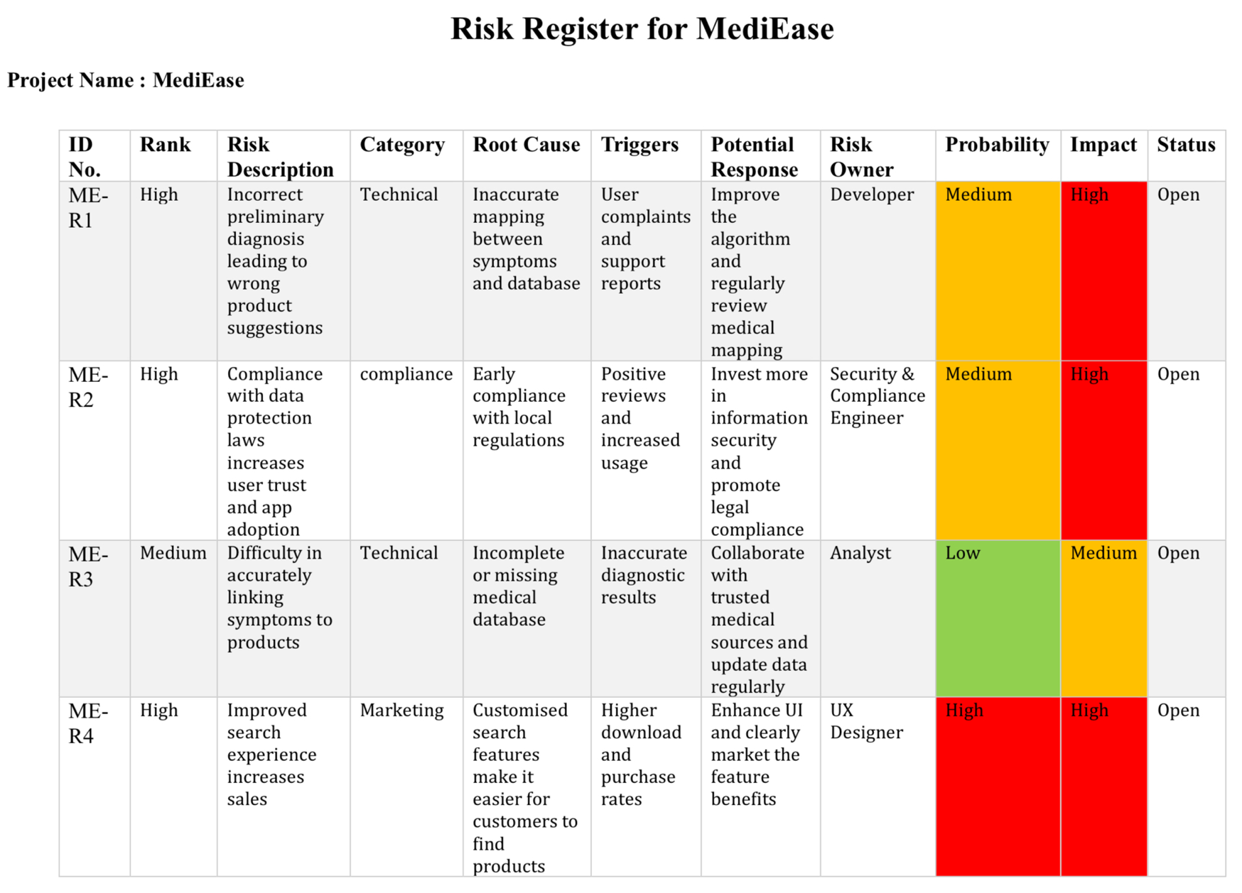

Figure9: Risk Register

# **12.References:**

[1] McKinsey & Company. (n.d.) Ten ways to accelerate the benefits of digital health in Saudi Arabia. Retrieved from <https://www.mckinsey.com/industries/healthcare/our-insights/ten-ways-to-accelerate-the-benefits-of-digital-health-in-saudi-arabia/ar-AE>

[2] Nahdi Pharmacy. Available: [https://www.alnahdionline.com](https://www.alnahdionline.com/). [Accessed: Mar. 8, 2025].

[3] Lucidchart. (n.d.) Tips for Writing Business Requirements Documents. Retrieved from <https://www.lucidchart.com/blog/tips-for-a-perfect-business-requirements-document>

[4] B. Matthews, “Understanding responsibility assignment matrix (RACI matrix),” *Project-Management.com*, Apr. 19, 2024. https://project-management.com/understanding-responsibility-assignment-matrix-raci-matrix/

‌[5] P. Mulder, “RACI Matrix / RACI Chart, a stakeholder management tool | toolshero,” *toolshero*, Nov. 10, 2013. https://www.toolshero.com/project-management/raci-matrix/

‌